Module Name: Practice Test Automation - Test Plan and RTM
Test Case ID: st_02
Webpage URL:https://practicetestautomation.com/logged-in-successfully

● Scenario ID: 1a

Scenario: Login with valid credentials
Test Steps:
- Enter username
- Enter password
- Click Login
Screenshots:
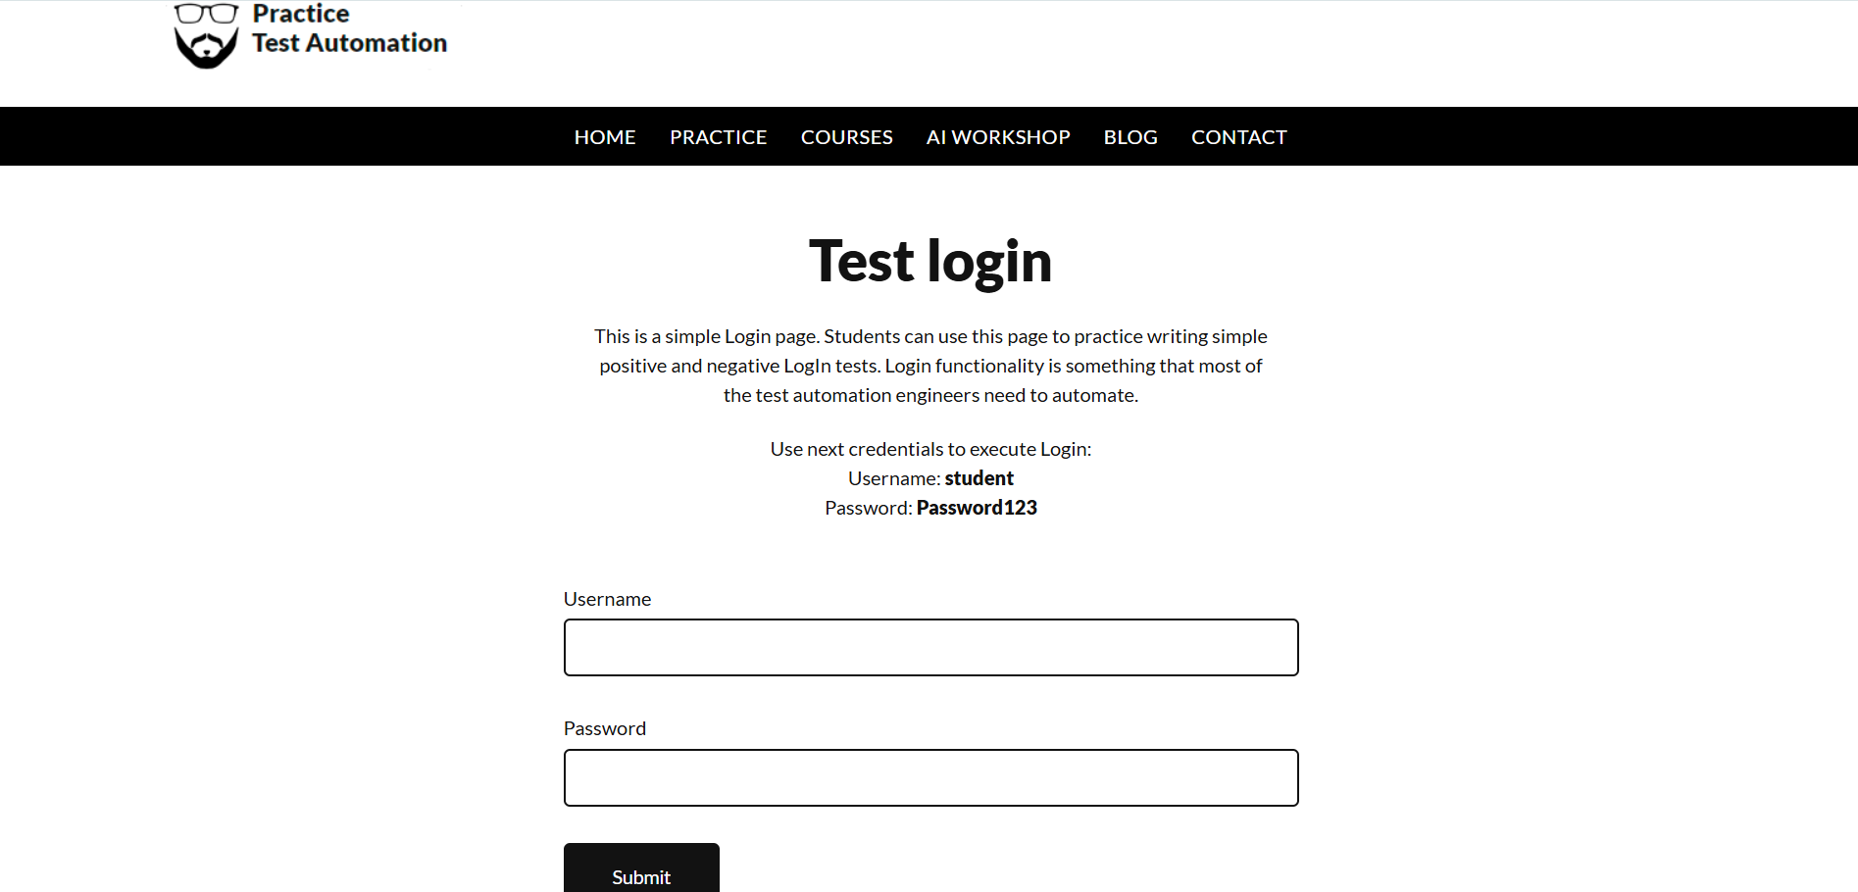
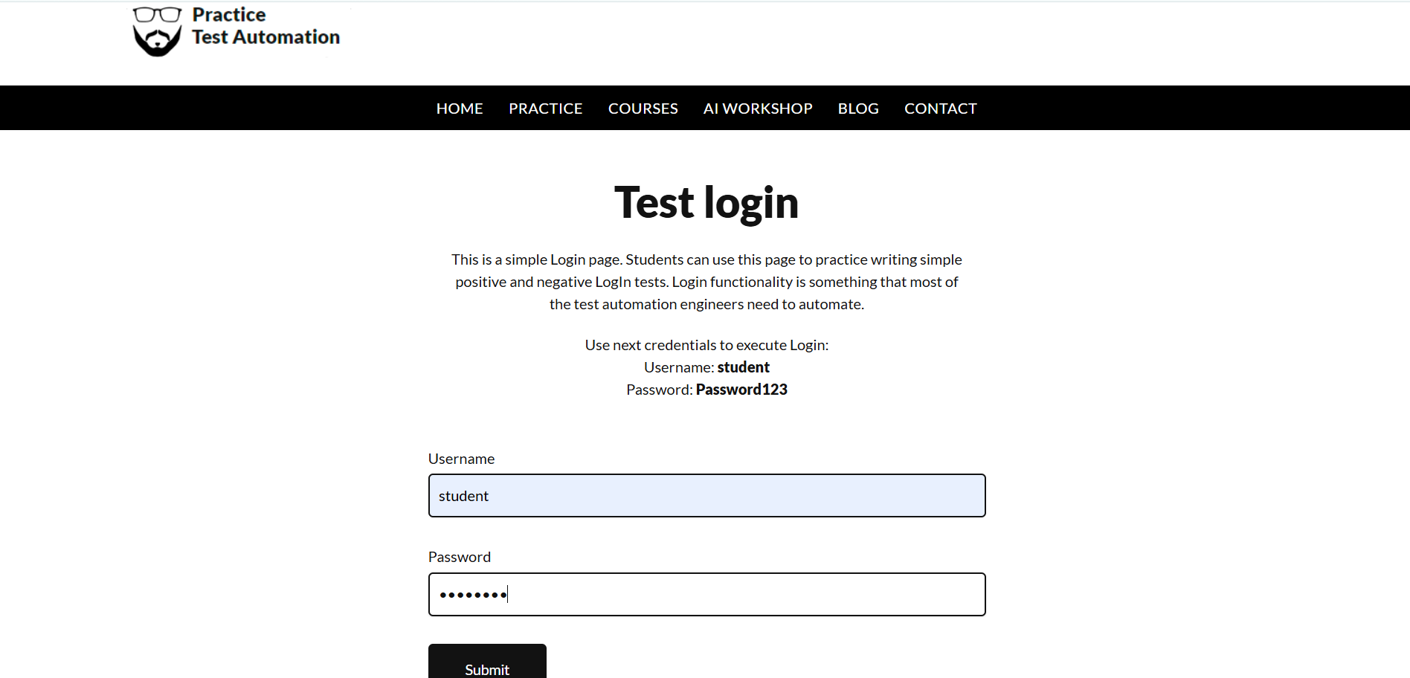
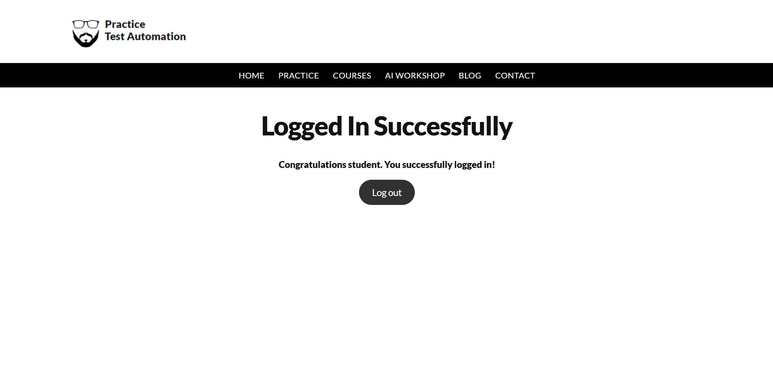
Actual Result :- Successful Login
Status:- Pass

● Scenario ID: 1b

Scenario: Login with invalid Password
Test Steps:
- Enter username
- Enter invalid password
- Click Login
Screenshots:
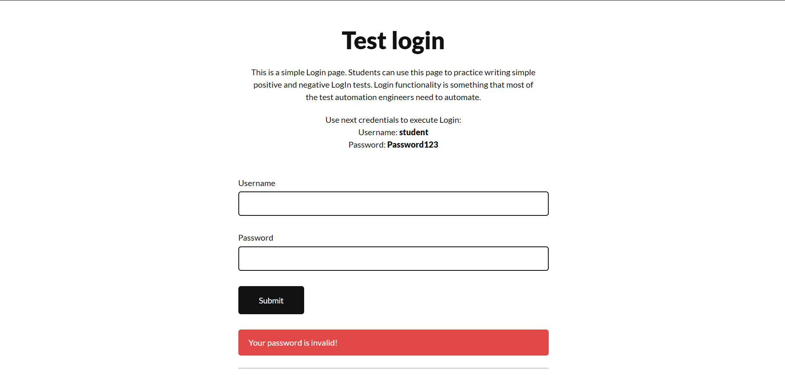

Actual Result :- Error shown
Status:- Pass

● Scenario ID: 1c

Scenario: Login with invalid username
Test Steps:
- Enter invalid username
- Enter password
- Click Login
Screenshots:
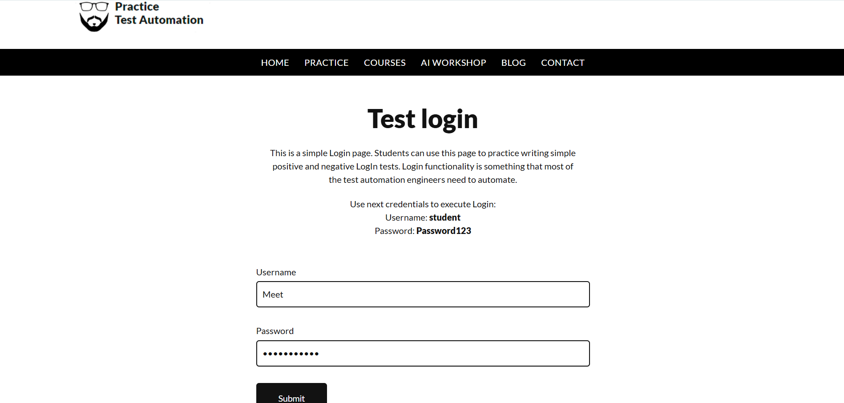
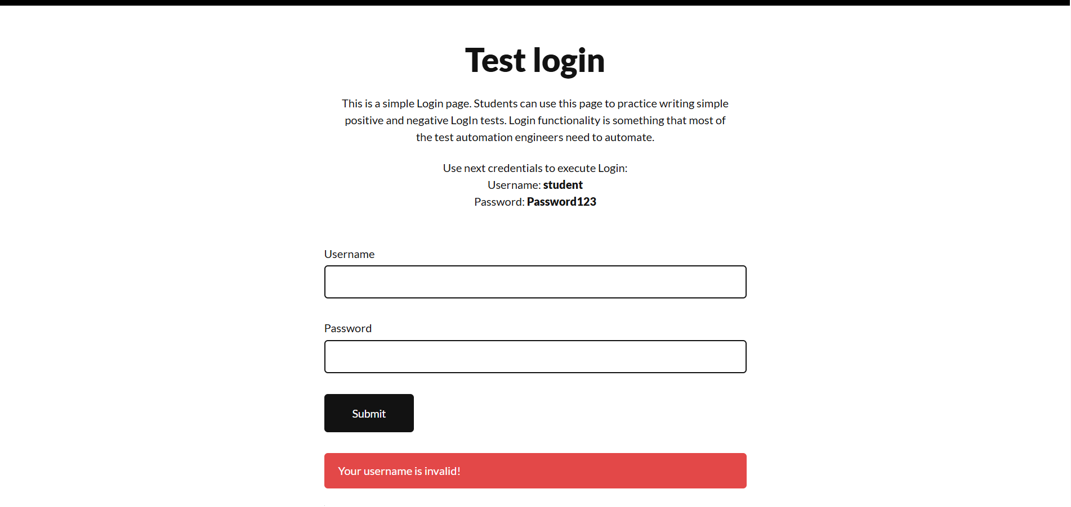

Actual Result :- Error shown
Status:- Pass

● Scenario ID: 1d

Scenario: Try Login with empty username
Test Steps:
- Enter username
- Blank password
- Click Login
Screenshots:
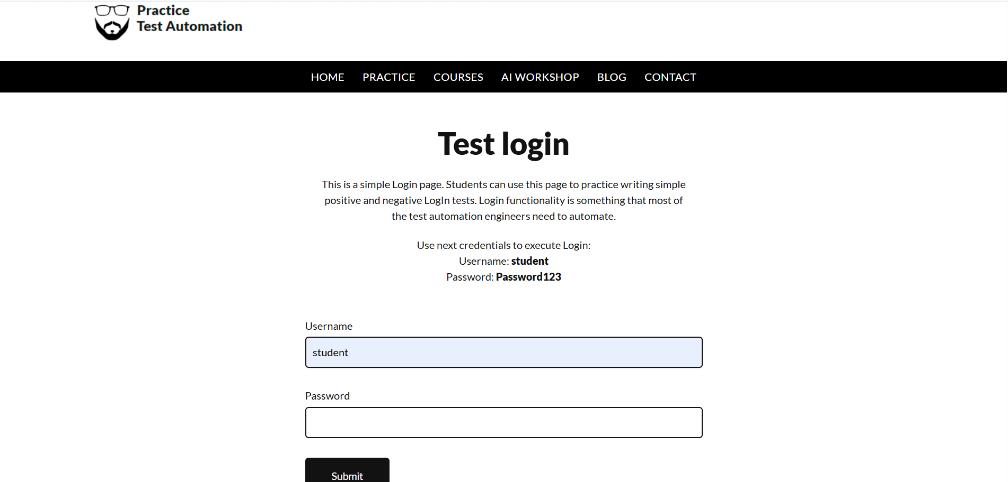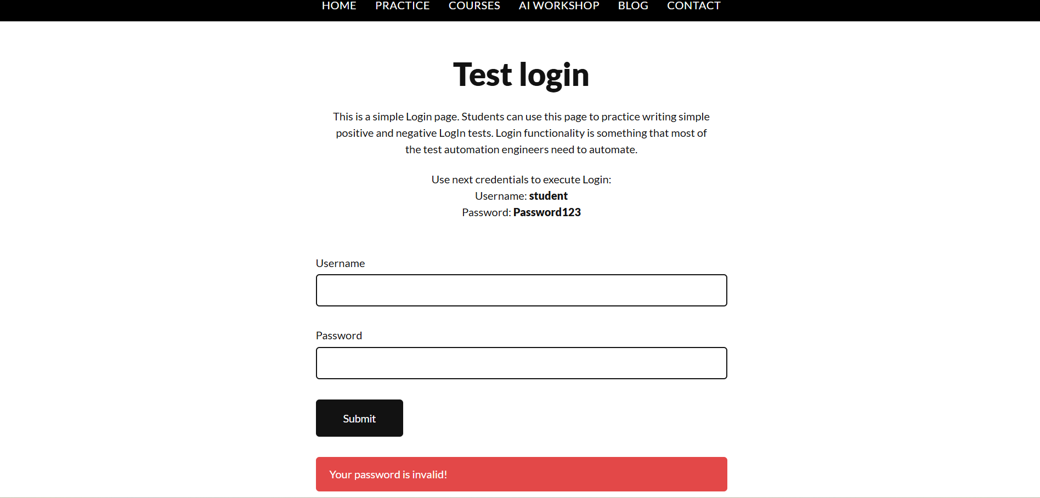

Actual Result :- Error shown
Status:- Pass

Scenario ID: 1e

Scenario: Try Login with empty password
Test Steps:
- Blank username
- Enter password
- Click Login
Screenshots:
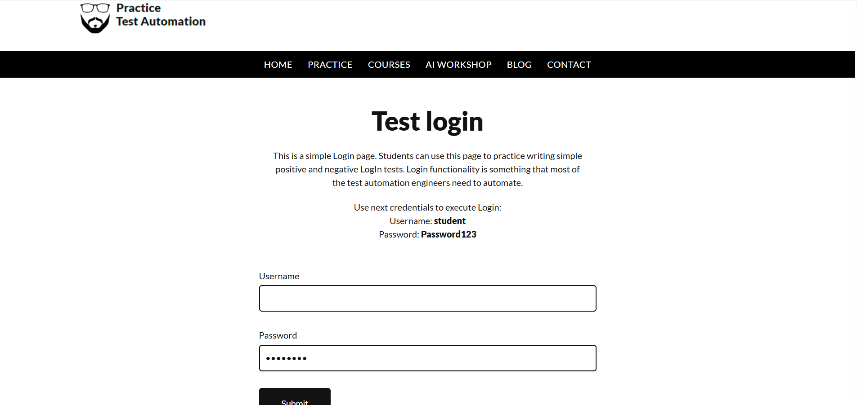
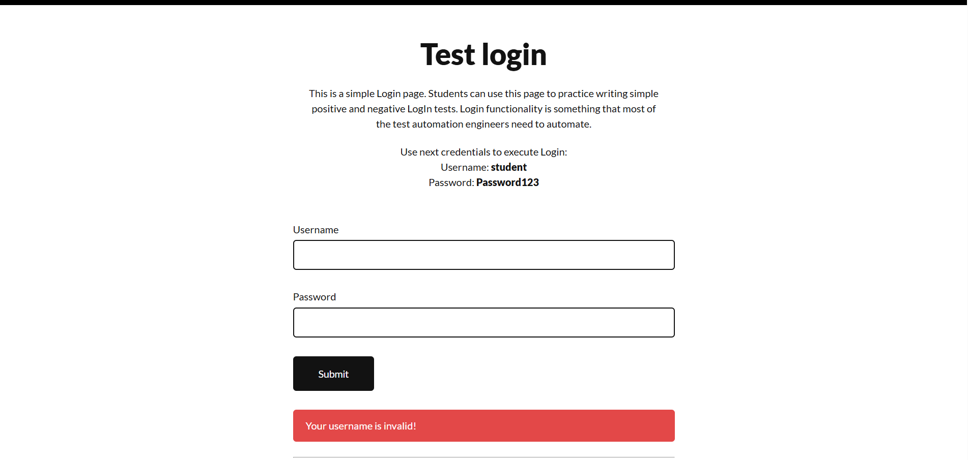

Actual Result :- Error shown
Status:- Pass

Scenario ID: 2a

Scenario: Test Exceptions Practice
Test Steps:
- Login
- Click practice
- Click Test exceptions
Screenshots: 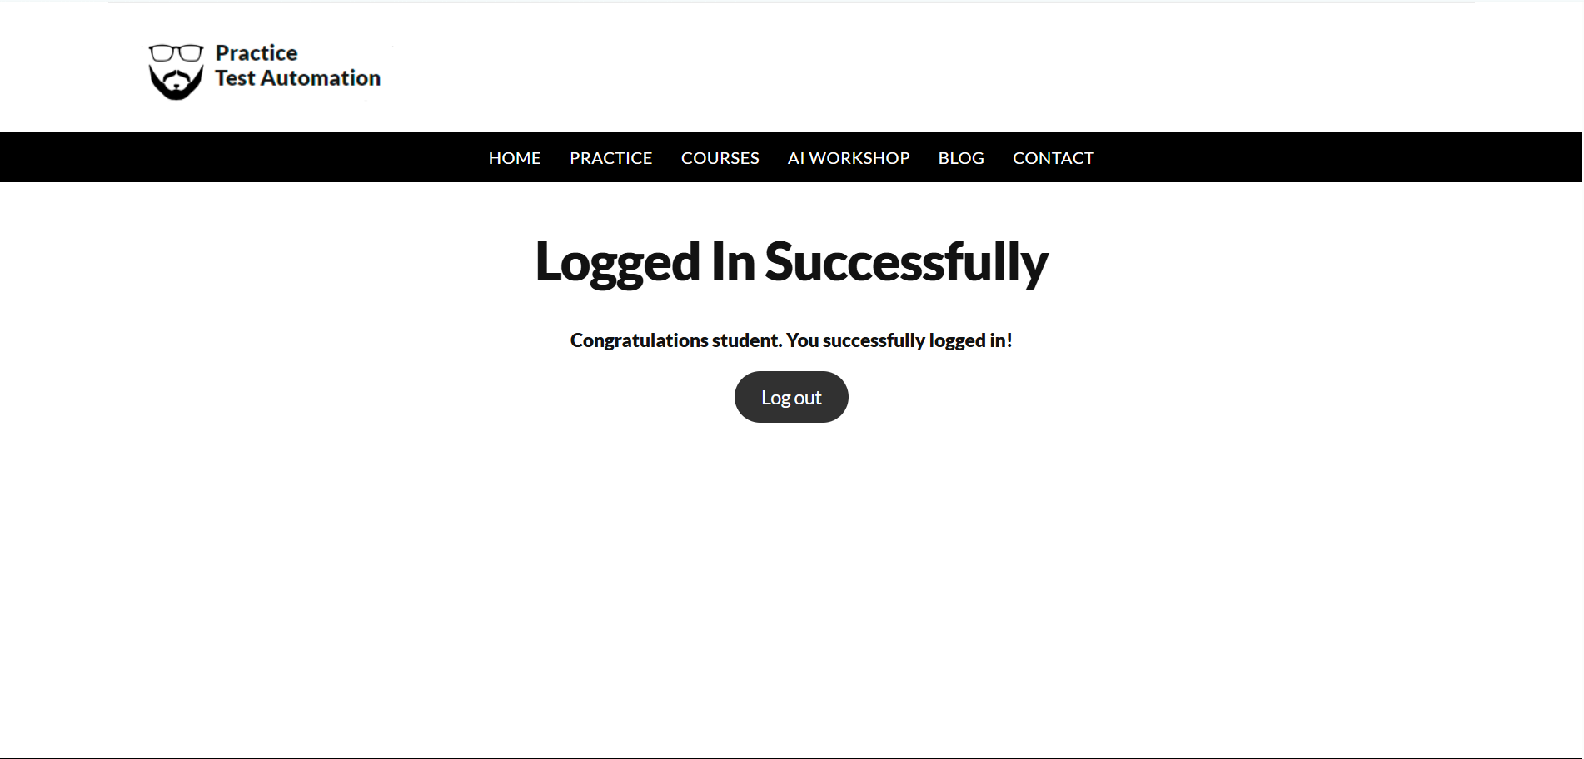
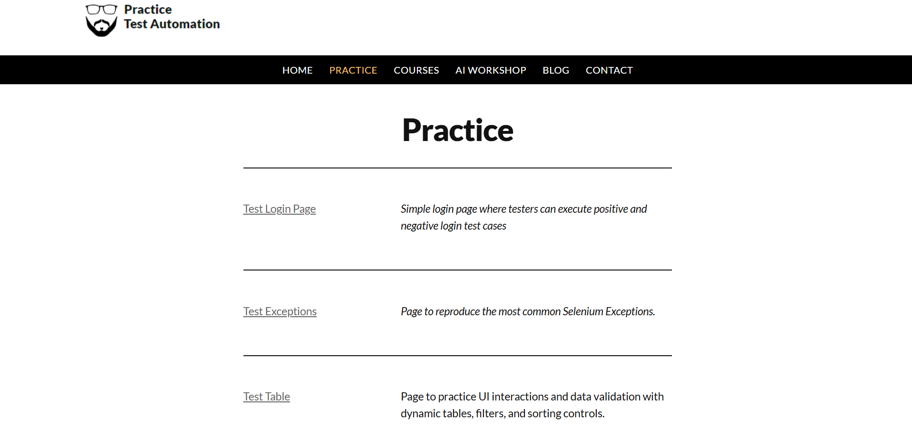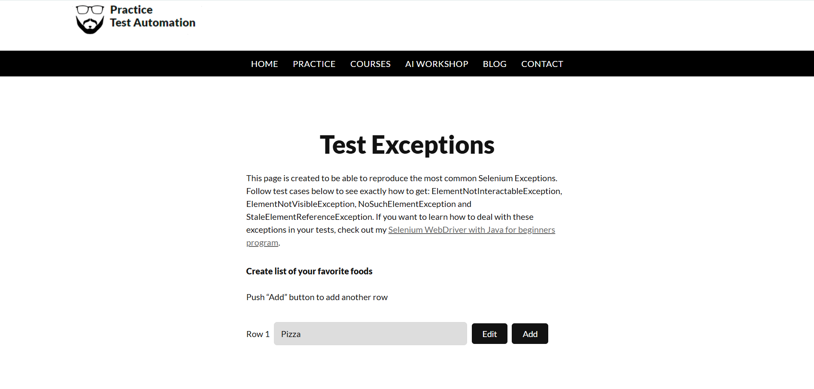
Actual Result :-Open Test table
Status:- Pass

Scenario ID: 2b

Scenario: Test Table Practice
Test Steps:
- Login
- Click practice
- Click Test table
Screenshots:
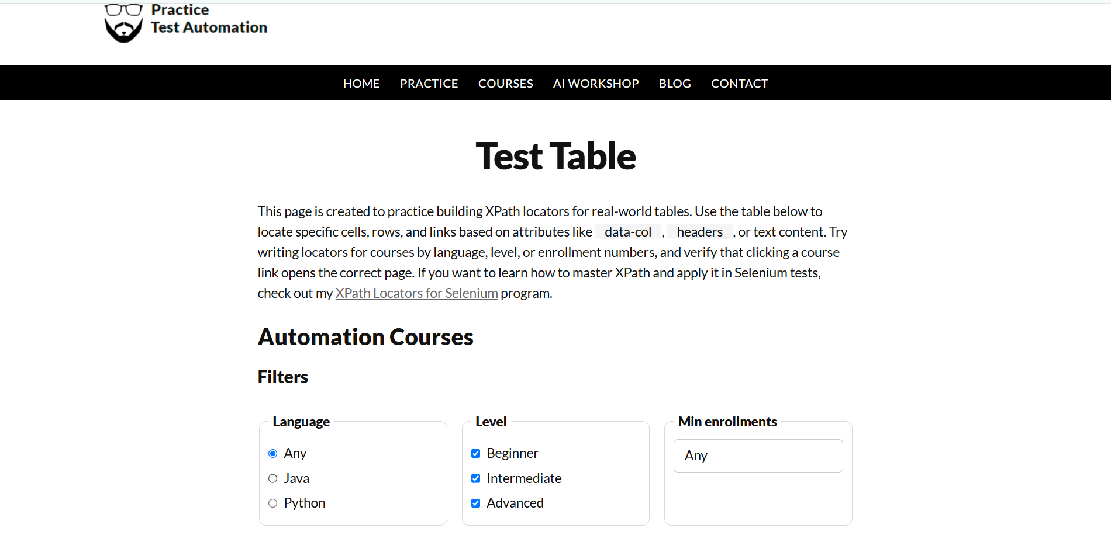

Actual Result :-Open Test exceptions
Status:- Pass

Scenario ID: 3a

Scenario: Logout a website
Test Steps:
- Enter username
- Enter Password
- Click Login
- Click Logout
Screenshots:

Actual Result :-Successfull Logout
Status:- Pass

